**Task :1**

**Task-1: Create your First page using the HTML structure**

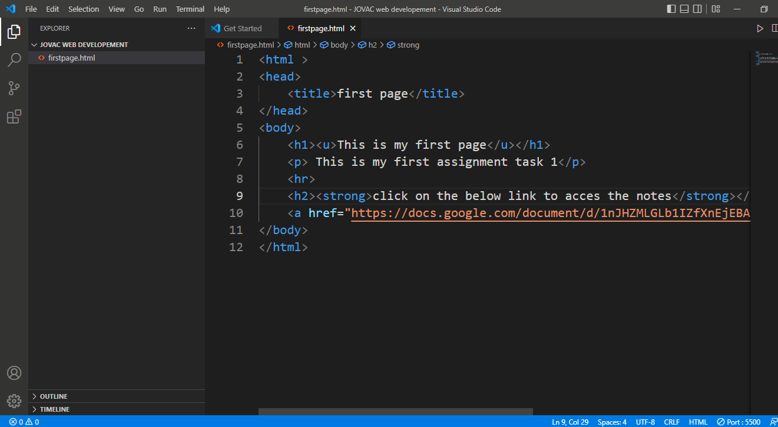

Output

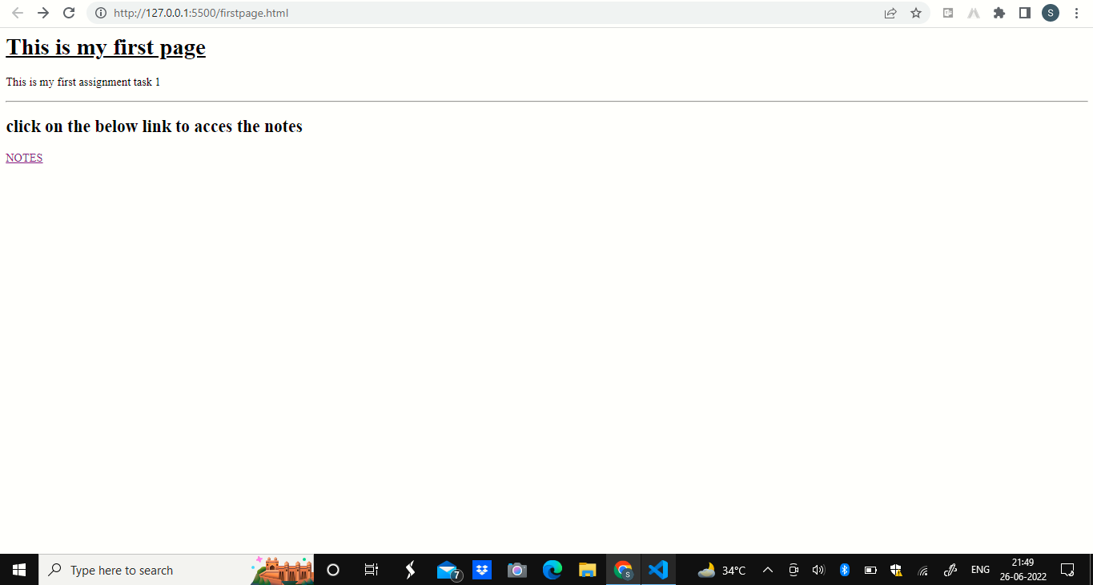

**Task-2: Create your Second page using VSCode Snippet.**

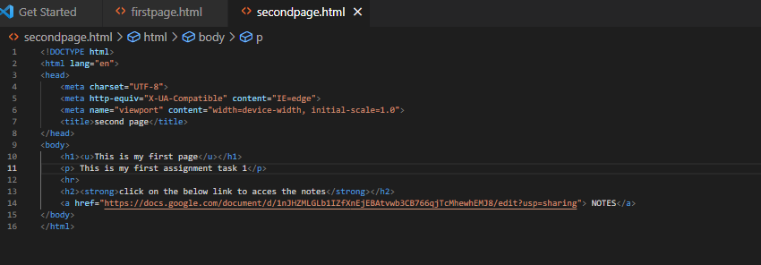

**Output:**

